Practical Assignment 04
4.1 Write an arrow function isEven(num) that if a number is even.
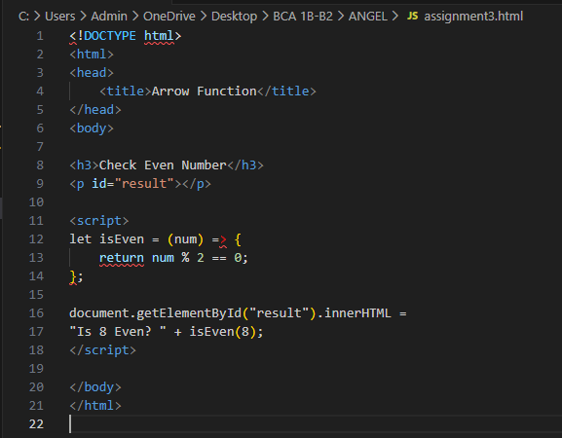

Output:
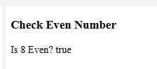

4.2 Create a multiple string using template literals showing a 3 – lime message.
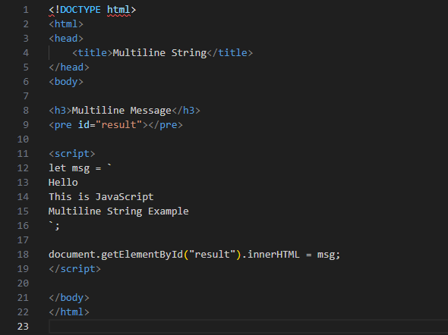

Output:
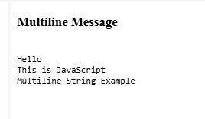
4.3 Merge two arrays using the spread operator.
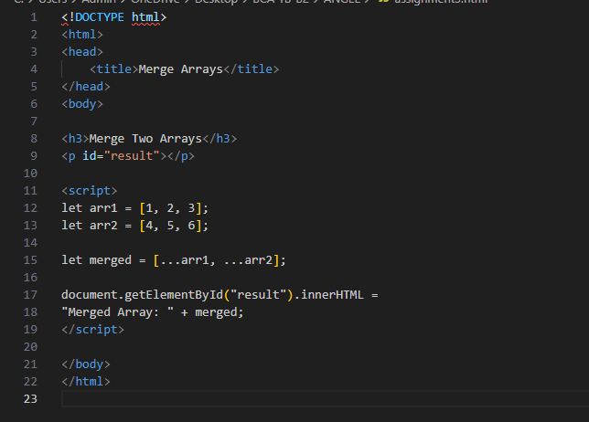

Output :
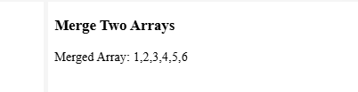

4.4 Add a click event to a button that changes the text of a paragraph .
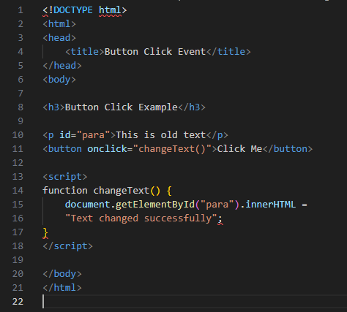
Output :
Before clicking:
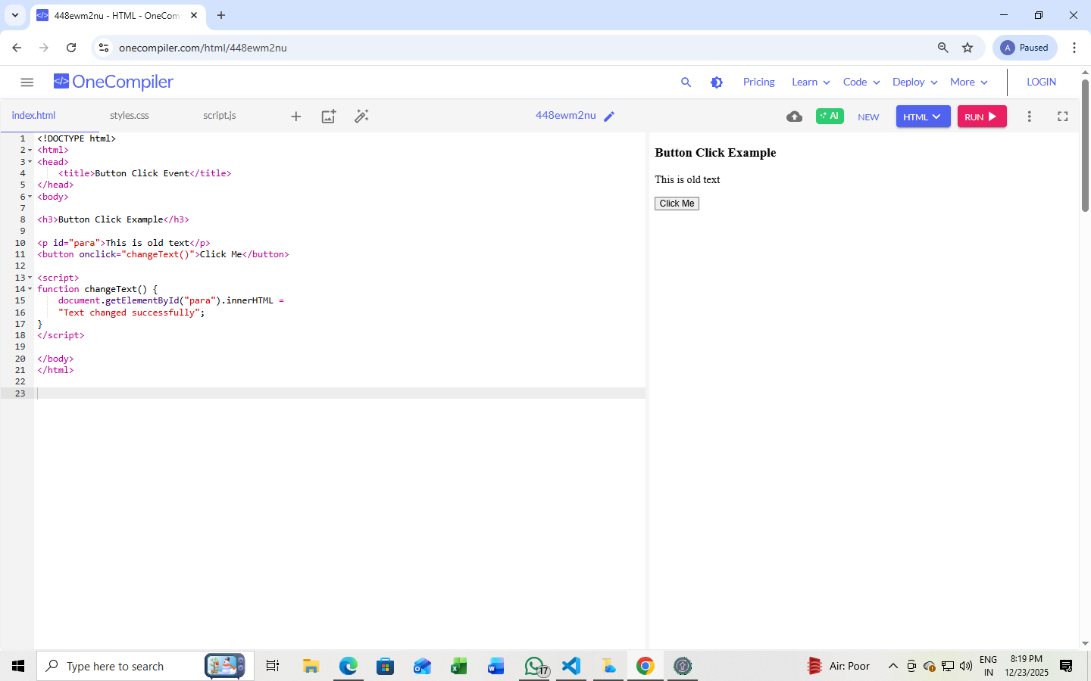
After clicking:
